A000-CAN-Mask-Tlingit-Wolf-Shaman-19th cent

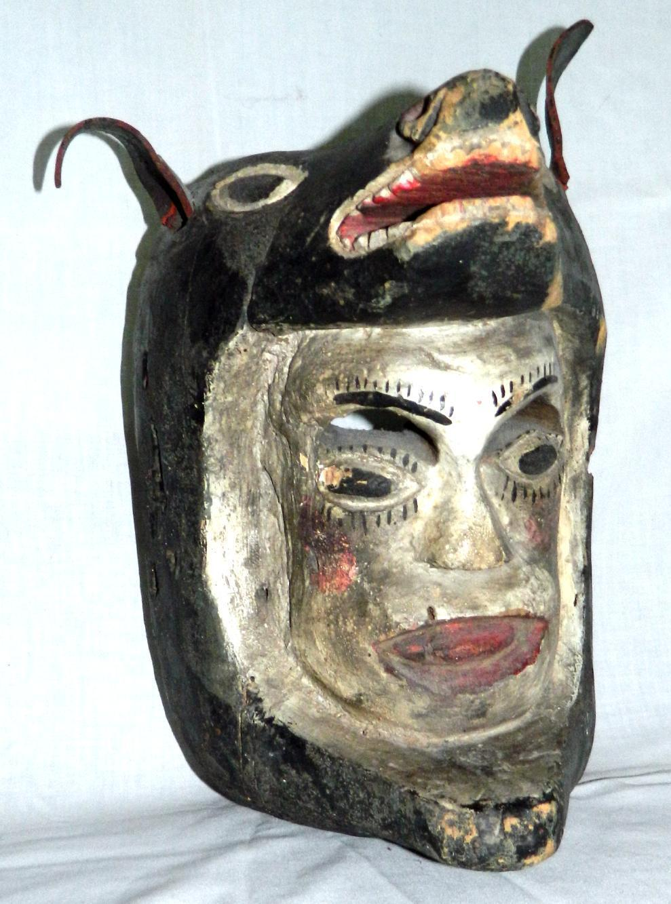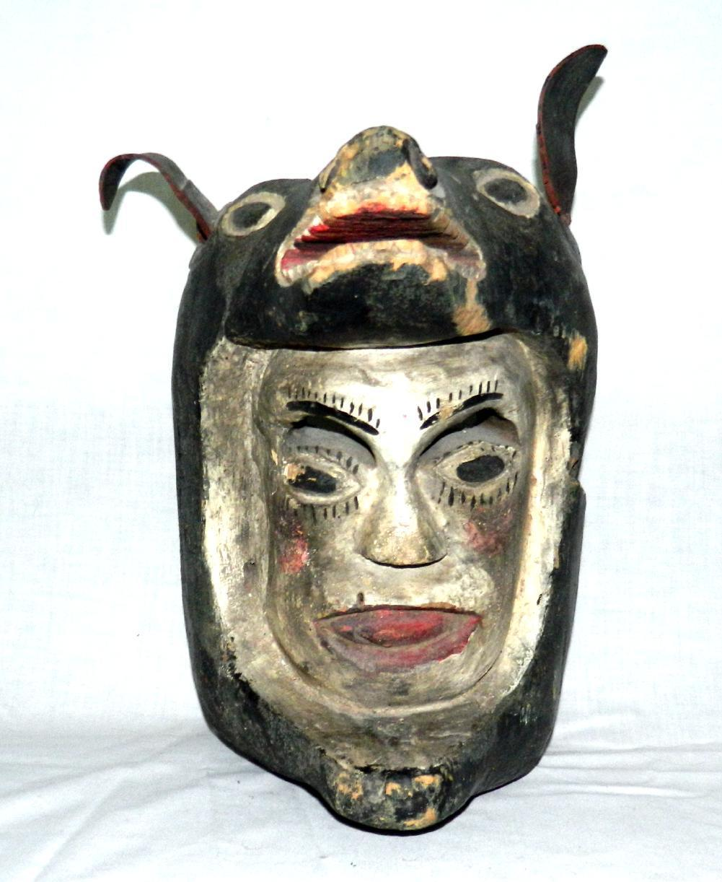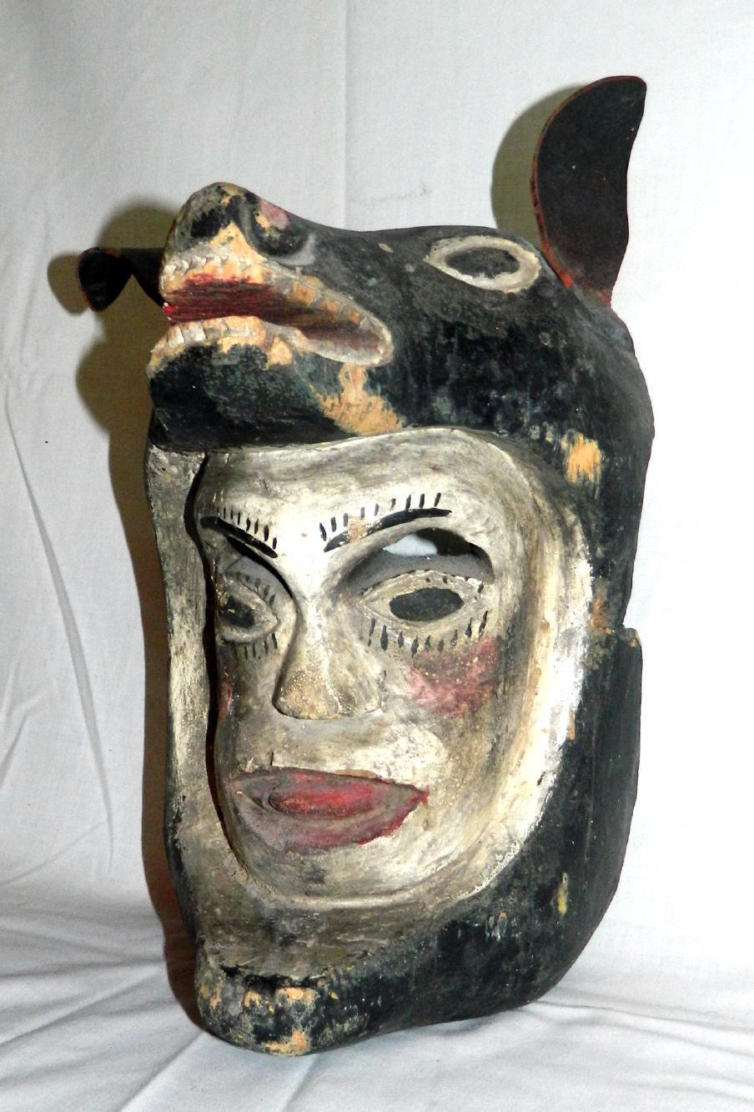

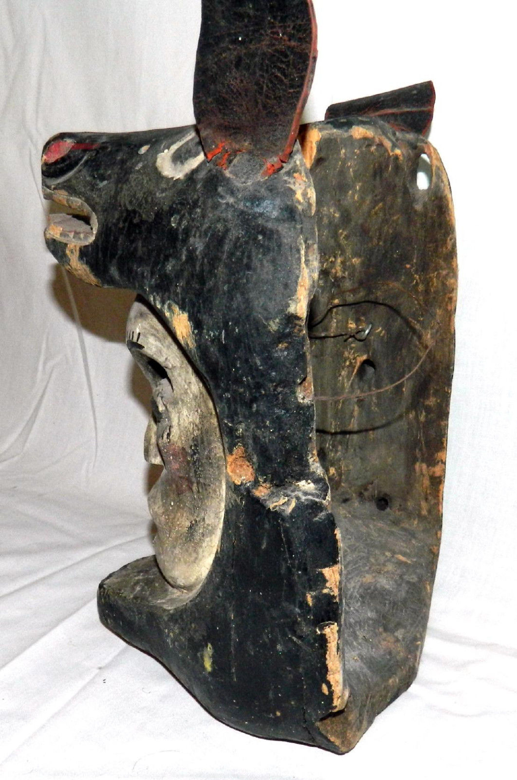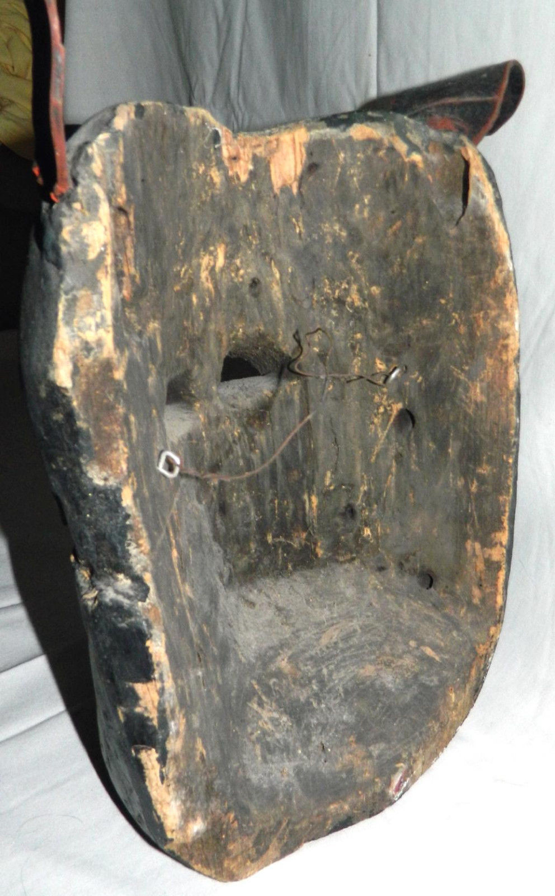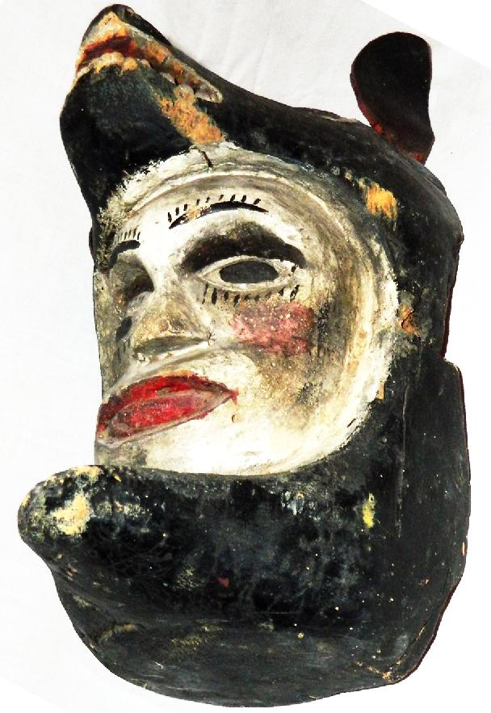

Case No.: 6

Formal Label: Tlingit shaman’s wolf transformation mask

Accession Number:

LC Classification:

Date or Time Horizon: 19th century

Geographical Area:

Cultural Affiliation: Tlingit

Medium: White pine wood, animal hide, black, red and white pigment.

Dimensions: Weight:

Provenance:

**Condition:**

**Discussion:**

**References:** This mask makes use of the Tlingit iconography of a dying man’s face mask identified by its white pigment and its open mouth. However, because the facial image is engulfed by a wolf’s open jaws, the individual shaman is not physically dying but dying to his mortal self and acquiring the supernatural being of the wolf spirit. Compare with Metropolitan Museum of Fine Art 1979.206.440, The Michael C.. Rockefeller Collection, bequest of Nelson A. Rockefeller Collection, 1979 (Wardwell: 2009: 147, fig. 157).

A Tlingit legend has it that a hunter who died in the sea becomes an orca and a hunter who dies on land becomes a wolf. The orca and the wolf were thus regarded as sacred to the hunter and there was a prohibition among the Tlingit against killing these animals (Curtis 1907-1930, 10:36).

**References:**

Curtis, Edward Sheriff. 1970; [i.e., 1907-1930]. *The North American Indian*. New York: Johnson Reprint. 10 vols.

Wardwell, Allen. 2009. *Tangible visions: Northwest Coast Indian Shamanism and its art*. New York: Monacelli Press.